 | 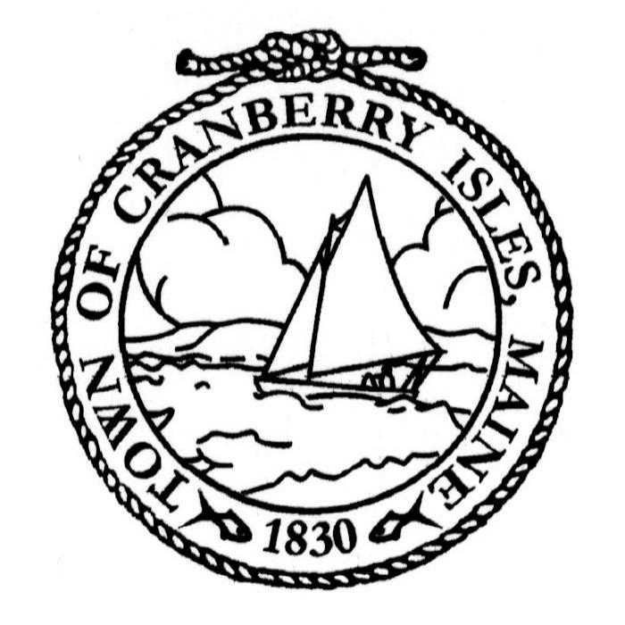
TCI SELECTBOARD |  | Adminstrative Assistant
Katelyn damon, CHAIRPERSON |  | TO THE SELECTBOARD
January Bennett |  | JAMES FORTUNE
TOWN CLERK / TREASURER |  | PUBLIC SAFETY COORDINATOR
DENISE McCORMICK |  | SHARON MORRELL
Establishing an Ad Hoc Committee for the Study of a transition to a
Town Manager form of Government

An application can be found online at:
https://forms.office.com/r/EeCHyeyXXE
Purpose:
The purpose of this ad hoc committee is to conduct a thorough study and evaluation of the feasibility, benefits, and potential challenges of transitioning the Town of Cranberry Isles to a town manager form of government. The committee will explore operational efficiencies, governance improvements, and fiscal implications associated with this governance model.

Scope and Objectives:
- Research:
The committee will:
  - Study the roles and responsibilities of a town manager in municipalities with similar demographics, including seasonal tourism, marine-based economies, and transportation challenges.
  - Evaluate existing governance structures and compare them with a town manager model. This evaluation will also include the feasibility of expanding the Select Board either as a concurrent event with the town manager transition or as a standalone process.
  - Analyze financial impacts, including salary, administrative adjustments, and long-term cost savings.
- Engagement:
  - Gather input from community members, local business owners, and other stakeholders.
  - Consult with experts, such as municipal governance consultants and town managers from similar municipalities.
- Reporting:
  - Develop a comprehensive report outlining findings, including potential benefits, risks, and recommendations.
  - Present the report to Selectboard for review and decision-making.

- Membership:
The committee will consist of 7 members appointed by the Select Board, after an application process is established. Membership should represent a diverse range of perspectives, including:
- Local residents
- Property owners
- Business owners
- Municipal staff or other elected officials familiar with governance operations
- Structure and Leadership:
Membership will be required to take an oath of office upon appointment.
- A chairperson, vice-chairperson and secretary will be elected from among the members.
- Meetings will be held monthly and will be open to the public, with agendas and minutes made available to ensure transparency.
- Remote participation is acceptable.
- Timeline:
- The committee will convene by April 15, 2025.
- The final report and recommendations will be submitted by December 1, 2025.
- Authority:
This committee is advisory in nature and will make recommendations to the Selectboard.
- Resources and Support:
The committee will have access to $2,000 in funds from the Selectboard contingency to use for travel, consulting and research as needed, to facilitate the study.

Next Steps from the Selectboard
- Announce the formation of the committee and invite applications or nominations for membership.
- Schedule the first joint meeting with the selectboard to, elect members and establish priorities and begin work on the study.

TCI SELECTBOARD |  | Adminstrative Assistant
Katelyn damon, CHAIRPERSON |  | TO THE SELECTBOARD
January Bennett |  | JAMES FORTUNE
TOWN CLERK / TREASURER |  | PUBLIC SAFETY COORDINATOR
DENISE McCORMICK |  | SHARON MORRELL
Study of Transition to a Town Manager Form of Government
Committee Member Application Form
Town of Cranberry Isles
You may also find this form online at:
https://forms.office.com/r/EeCHyeyXXE

Thank you for your interest in serving on the Committee for the study of a potential transition to a town manager form of government. Please complete the following application form to be considered for an appointment.

1. Personal Information
- Full Name:__________________________________________________________
- Address: ____________________________________________________________
- Phone Number: ______________________________________________________
- Email Address: ______________________________________________________
- Preferred Method of Contact (circle one): Phone, Email, No preference

2. Eligibility Requirements
- Are you a resident of the Town of Cranberry Isles (circle one) ?
  - Yes
  - No
- If no, please explain your connection to the community.

3. Relevant Experience and Skills
Please briefly describe your background and experience that you feel would contribute to the work of the Ad Hoc Committee. (For example: public service, business ownership, municipal governance, legal or financial expertise, knowledge of local issues, etc.)

4. Reason for Interest
Why are you interested in serving on this Ad Hoc Committee? What do you hope to contribute to the study of the transition to a town manager form of government?

5. Availability
Committee members are expected to attend regular meetings, which may be held monthly or more frequently as needed will require additional time for research. Please indicate your availability and commitment to attend meetings:
- Are you able to attend monthly meetings (circle one)?
  - Yes
  - No
  - Occasionally (please specify availability):

6. Conflict of Interest
To ensure transparency and integrity in the committee’s work, please disclose any potential conflicts of interest, including financial, professional, or personal relationships that could influence or appear to influence your participation on the committee.
- Do you have any potential conflicts of interest (circle one)?
  - No
  - Yes (please describe):

7. References
Please provide the names and contact information of two references who can speak to your qualifications and character:
- Reference Name:

  - Phone Number:

  - Email Address:

- Reference Name:

  - Phone Number:

  - Email Address:

8. Additional Information
Please use the space below to provide any additional information you believe is important for your application:

Certification and Agreement
By submitting this application, I certify that the information provided is accurate and complete to the best of my knowledge. I understand that submitting this application does not guarantee an appointment to the Ad Hoc Committee.

Signature:

Date:

Submission Instructions:
Completed applications can be submitted in one of the following three ways:

- By Email:
Send your completed application to Selectboard Chair, katelyn@cranberryisles-me.gov

- By Mail:
Mail your completed application to:
PO BOX 56
Islesford, Maine 04646

- In Person:
Drop off your application at:
Town of Cranberry Isles Town Office
61 Main Street
Islesford, Maine 04646

Deadline for Submissions:
All applications must be received by March 15, 2025.

